BLACK LENSES

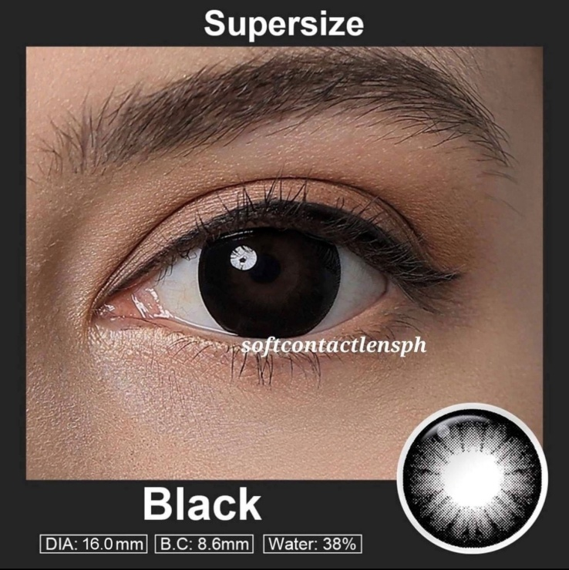

**DIA: 16.0mm**

**B.C: 8.6mm**

**WATER: 38%**

Black contact lenses are a type of colored contact lenses that feature a deep, opaque black color. They are designed to completely cover the natural eye color, creating a striking and dramatic effect. These lenses are often used for special occasions, costume parties, or theatrical performances to achieve a specific look or character. Black contact lenses are typically made from soft, breathable materials such as silicone hydro gel. These materials allow for comfortable wear and maintain good oxygen flow to the eyes. It is important to note that black contact lenses, like any other contact lenses, should be prescribed and fitted by a qualified eye care professional. They require proper care and maintenance, including regular cleaning and storage according to the manufacturer's instructions. It is crucial to follow the recommended wearing schedule and replace the lenses as directed to ensure eye health and prevent any potential complications. Before considering the use of black contact lenses, it is highly recommended to consult with an eye care professional. They can assess your eye health, provide a proper fitting, and guide you on the safe and appropriate use of these lenses based on your individual needs and eye condition.